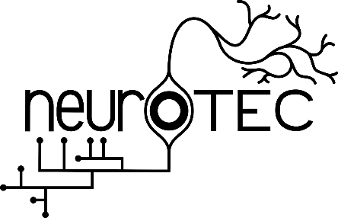
The Weill Neurohub & NeuroTEC
Student Travel Award

The Weill Neurohub was established with the exceptional generosity of the Weill Family Foundation to speed the development of new treatments for neurological and psychiatric diseases by funding the development of high-impact projects that leverage imaging, engineering, genomics and molecular therapies, and computation and data analytics. The Weill Neurohub prioritizes the support of collaborative research projects with near-term transformational potential, novel research ideas led by pioneering investigators, and the training of the next generation of clinicians and scientists. In partnership with the University of Washington’s Neurotechnology, Engineering and Computation (NeuroTEC) student organization, the Weill Neurohub has extended financial support for graduate and undergraduate students advancing research in the fields of neurotechnology, neural engineering, and computational neuroscience.

Graduate and undergraduate students are invited to apply for travel awards for both domestic and international destinations to attend conferences, workshops, or participate in cross-institutional collaborative work.

Eligibility
Students applying for travel awards must be a graduate or undergraduate student at the University of Washington. Each applicant is eligible for one travel award per fiscal year (July 1st through June 30th).

Award Type
Students are welcome to submit travel awards applications for any research-related travel including conferences, workshops, or cross-institutional engagement, and travel awards may be used to cover the cost of travel, lodging, food, and registration expenses. Total award amounts will be up to $500 for domestic and up to $1000 for international travel, and awards will be made in the form reimbursements through the CSE department at UW.

Application Requirements
Please submit completed application to prattb@uw.edu. Applications will be reviewed within a couple of weeks and awardees will be notified via email. Note that applications should be submitted within a month of the conference to allow the awarding committee to have enough time to decide on the acceptance of the application.

Reimbursement Process
Reimbursements will be processed by Lisa Merlin (lmerlin@cs.washington.edu) of the CSE department. After the conference or workshop, please submit all receipts related to travel, lodging, food, and registration fees to Lisa, with a total to be reimbursed – stating that the reimbursement will come from the NeuroTEC travel Grant.

Conditions and Responsibilities of Award
  - Award recipient must attend the meeting described in the application.
  - Receipts for travel and conference-related expenses must be submitted to Lisa Merlin to access the awarded travel funds.
  - Award recipients must give a NeuroTEC Student Research Lunch Talk or a podcast interview related to the conference presentation or workshop.
NeuroTEC Travel Grant
Student Travel Award

Application Form (please type)

Student Name (First and Last): Click or tap here to enter text.

Student Department Affiliation: Click or tap here to enter text.

Student Telephone number: Click or tap here to enter text.

Student E-mail address: Click or tap here to enter text.

Graduate student ☐ Undergraduate student ☐

Current Year in Program: Click or tap here to enter text.
Faculty Sponsor or PI Name/Department Affiliation: Click or tap here to enter text.

Faculty Sponsor or PI E-mail address: Click or tap here to enter text.

NeuroTEC Travel Grant
Student Travel Award

Conference/Workshop: Click or tap here to enter text.

Travel Dates: Click or tap here to enter text.

Travel Destination: Click or tap here to enter text.

Presentation Type (Oral or Poster): Click or tap here to enter text.

Presentation Author List: Click or tap here to enter text.

Presentation Title: Click or tap here to enter text.

Presentation Abstract:
Click or tap here to enter text.

Personal Statement (State your personal aims for the conference or workshop):
Click or tap here to enter text.

